Deep learning
- Deep belief networks
- Deep Boltzmann machines
- Deep Convolutional neural networks
- Deep Recurrent neural networks
- Hierarchical temporal memory

Deep learning also known as deep structured learning, hierarchical learning or deep machine learning.
Deep learning is part of a broader family of machine learning methods based on learning representations of data.
Note:
Learning Representation or Feature Learning:
In machine learning, feature learning or representation learning is a set of techniques that learn a feature: a transformation of raw data input to a representation that can be effectively exploited in machine learning tasks.
This obviates manual feature engineering
Coming up with features is difficult, time-consuming, requires expert knowledge. "Applied machine learning" is basically feature engineering. — Andrew Ng
Feature learning can be divided into two categories:
1. Supervised Feature learning
Features are learned with labeled data.
Example: neural networks, multilayer perceptron, and (supervised) dictionary learning.
2. Unsupervised feature learning
Features are learned with unlabeled data.
Examples: dictionary learning,independent component analysis, sparse autoencoders, matrix factorization, and various forms of clustering

Choice of Deep Net
---------------------------
1. Unlabeled data

Restricted boltzmann machines (RBN)
or
Autoencoders

2. Labeled data

Text Processing  Image Recognition  Object Recognition  Speech Recognition | RNTN(Recursive Neural Tensor Network),  Recurrent Net  DBN, Convolutional Net(CN)  RNTN, CN  Recurrent Net

3. General
Classification - MLP/RELU, Deep Beleif Net
Time series Analysis - Recurrent net

What is Perceptrons
- Developed in the 1950s and 1960s by the scientist Frank Rosenblatt
How do perceptrons work?
A perceptron takes several binary inputs, x1,x2,…, and produces a single binary output:
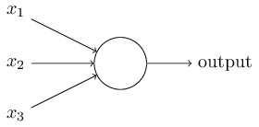

- perceptron has three inputs, x1,x2,x3.

- Rosenblatt proposed a simple rule to compute the output.

- He introduced weights, w1,w2,…, real numbers expressing the importance of the respective inputs to the output.
- The neuron's output, 0 or 1, is determined by whether the weighted sum ∑jwjxjis less than or greater than some threshold value.

- Just like the weights, the threshold is a real number which is a parameter of the neuron.

Output=0 if ∑jwjxj≤ threshold
1 if ∑jwjxj> threshold
- For example:
The weekend is coming up, and you've heard that there's going to be a cheese festival in your city. You like cheese, and are trying to decide whether or not to go to the festival. You might make your decision by weighing up three factors:

1. Is the weather good?
2. Does your boyfriend or girlfriend want to accompany you?
3. Is the festival near public transit? (You don't own a car).
We can represent these three factors by corresponding binary variables x1,x2, and x3.
For instance,
- we'd have x1=1 if the weather is good,
and x1=0 if the weather is bad.
- Similarly, x2=1 if your boyfriend or girlfriend wants to go, and x2=0 if not.
- And similarly again for x3 and public transit.

Aritifical Neural Network
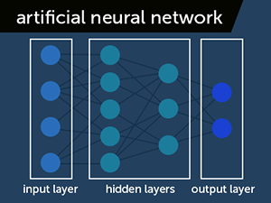

Linear vs Non Linear Seperation:

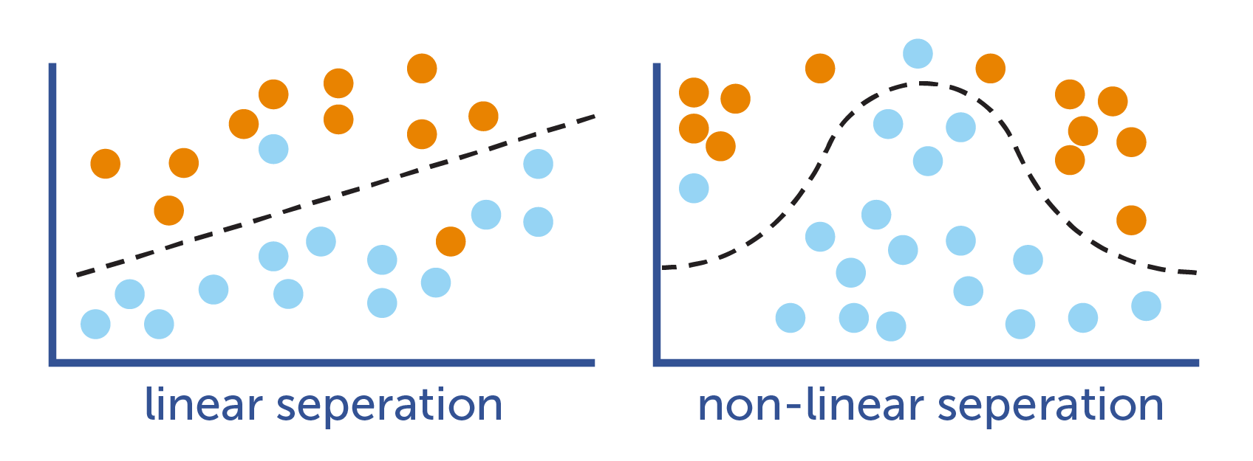

Activation Function:
Activation function is a function that transforms a set of input signals into an output signal.
This is not to be confused with non-linear transformations from deep learning (GRU, LSTM and so on), because everything you see there has a slightly different purpose - they are more about the representation of a hidden state.

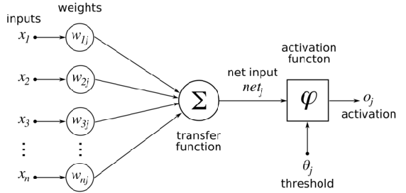
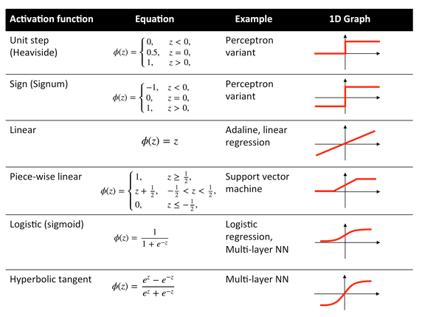
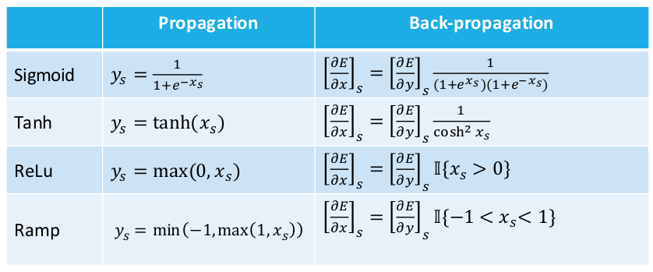
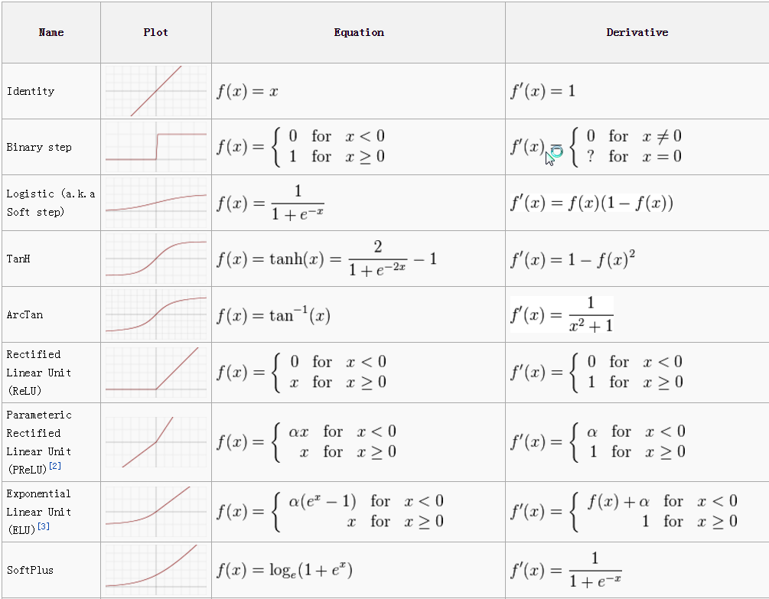

Note:
In the neural network terminology:
- one epoch = one forward pass and one backward pass of all the training examples
- batch size = the number of training examples in one forward/backward pass. The higher the batch size, the more memory space you'll need.
- number of iterations = number of passes, each pass using [batch size] number of examples. To be clear, one pass = one forward pass + one backward pass (we do not count the forward pass and backward pass as two different passes).
Example: if you have 1000 training examples, and your batch size is 500, then it will take 2 iterations to complete 1 epoch.

Recurrent network:
---------------------------
From http://colah.github.io/posts/2015-08-Understanding-LSTMs/ :
Humans don’t start their thinking from scratch every second. As you read this essay, you understand each word based on your understanding of previous words. You don’t throw everything away and start thinking from scratch again. Your thoughts have persistence.
Traditional neural networks can’t do this, and it seems like a major shortcoming. For example, imagine you want to classify what kind of event is happening at every point in a movie. It’s unclear how a traditional neural network could use its reasoning about previous events in the film to inform later ones.
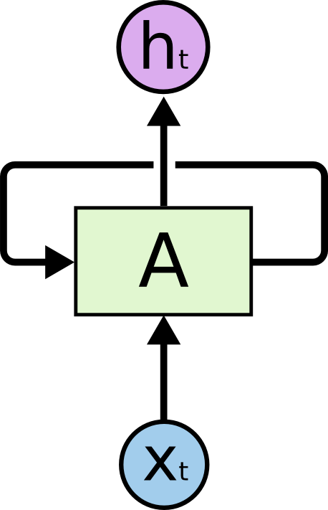
Recurrent neural networks address this issue. They
are networks with loops in them, information to persist.

